*Florida International University*

*School of Computing and Information Sciences*

Software Engineering Focus

Feature Document

User Story ID 788

**Name:** Set Notifications Settings

**Team Member(s):** Leandro Gonzalez,Luis Herrnsdorf

**Project:** Smart Stormwater (Smart City System) 2.0

**Product Owner(s)**: Emilio Lopez

**Mentor(s)**:

**Instructor**: Masoud Sadjadi

**User Story Name:** Set Notifications Settings

* Description: As a User, I would like to be able to change the settings for my notifications, so that I am able to control what types of notifications I receive

Acceptance Criteria

* The Notifications Settings page can be reached from anywhere in the app
* The current settings are displayed to the user
* Users can select ‘SMS’ and ‘Email’ as Notification Type
* Users can set the ‘Fill Level’
* Users can update the existing settings and save/cancel the changes

**Use Case**

* Name: SetNotificationsSettings001
* Actor: User
* Preconditions: User is logged in
* Description: Anywhere on the application, the logged in user can click on the dropdown menu that appears on the top right corner. After clicking on “Settings”, the user is redirected to the “Notifications Settings” page, containing a form with the user’s current notifications settings. The form contains a checkbox for email notifications, an additional checkbox for sms notifications, and a spinner to input the fill level that will trigger the notifications. The user can modify the settings and save, or leave the page, in which case it will be notified that any unsaved changes will be lost

**Use Case Diagram**

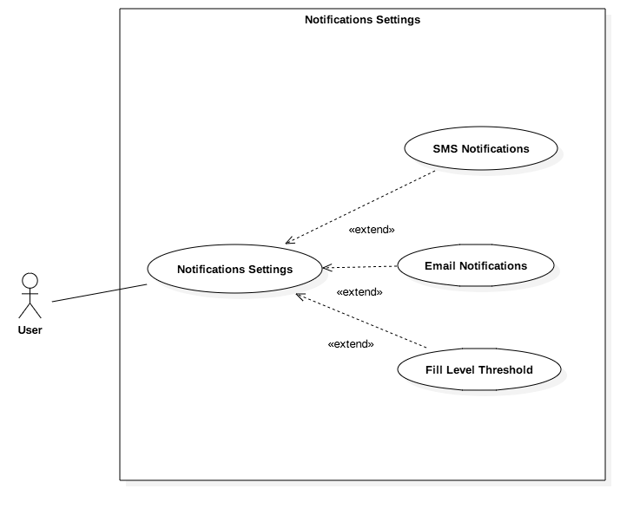

**Sequence Diagram**

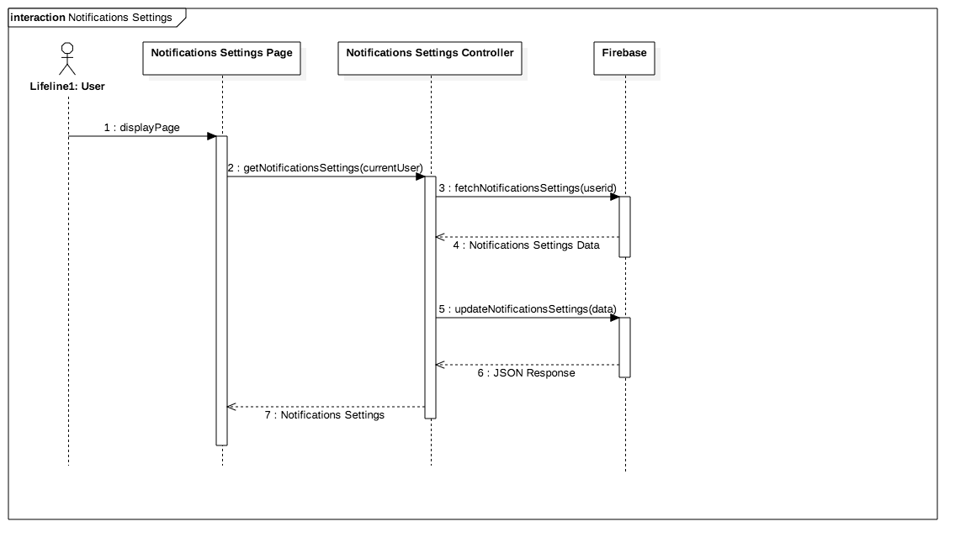

**Class Diagram**

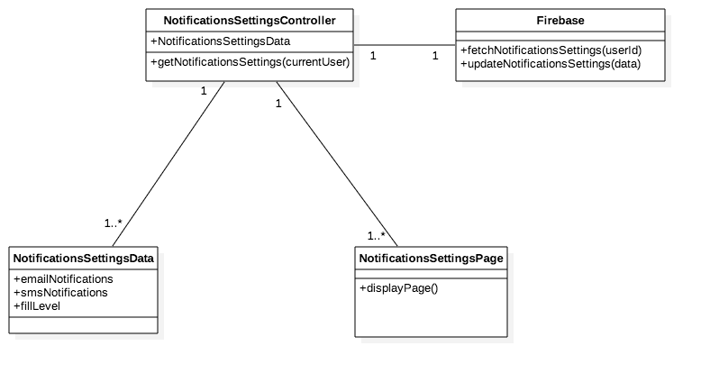

**Unit Test**

* Test case ID: ChangeSettings001
* Description/Summary of Test: User changes his/her notifications settings
* Pre-condition: User is logged in
* Expected Results: Changes are saved
* Actual Result: Changes made to the notifications settings have been updated
* Status (Fail/Pass): Pass

**Visual User Guide**

